
Year 2: Spring term 2
Topics studied this half term:
- Mass, capacity and temperature
- Investigations

Within mass, capacity and temperature, your children will be learning:

- Compare mass
- Measure mass in grams
- Measure mass in kilograms
- Compare volume
- Millilitres
- Litres
- Temperature

Tips for good homework habits:
If your child is struggling, don’t give them the answer in order to finish the homework quickly. Instead, talk through the task together and help them to arrive at the solution themselves.

Measurement
(volume and capacity)
HERE’S THE MATHS
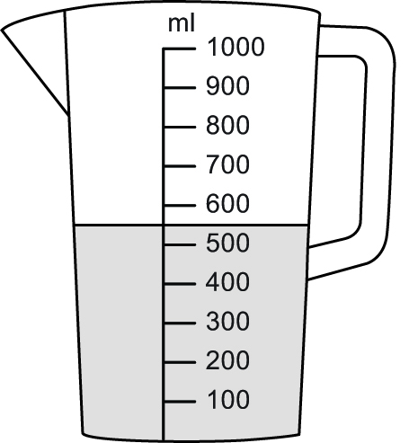
Your child has been reading the scale on measuring jugs
(to the nearest 100 ml). They have also been learning to compare containers and, without measuring, decide whether they hold more or less than 1 litre.

ACTIVITY
What to do
You will need:
- a range of kitchen containers such as spoons, cups, bowls, jugs, saucepans, buckets
- kitchen sink
- measuring jug marked
in millilitres and litres
- pencil and paper
- Give your child a range of containers and a measuring jug.
- Challenge them to organise the containers into two groups: containers they think will hold less than 1 litre and containers they think will hold more than 1 litre.
- Work with them to fill each container in turn and then pour the water into the measuring jug to find out the capacity of each container. As they work through the containers, make notes on paper about the containers and their capacities.
- Ask them to order the containers in capacity order, from smallest to largest.
Variation
- Challenge your child to organise the containers into two groups: one where they think the containers will hold less than 1 litre and the other where they think the containers will hold more than 1 litre. Give your child a litre jug or container to test their predictions by pouring 1 litre of water into each of the containers.
QUESTIONS TO ASK
How many millilitres/litres
of water does the cup/saucepan/bowl/
bucket hold?
How did you read the scale to work out how much water is in the jug?
Which container has the smallest/largest capacity?
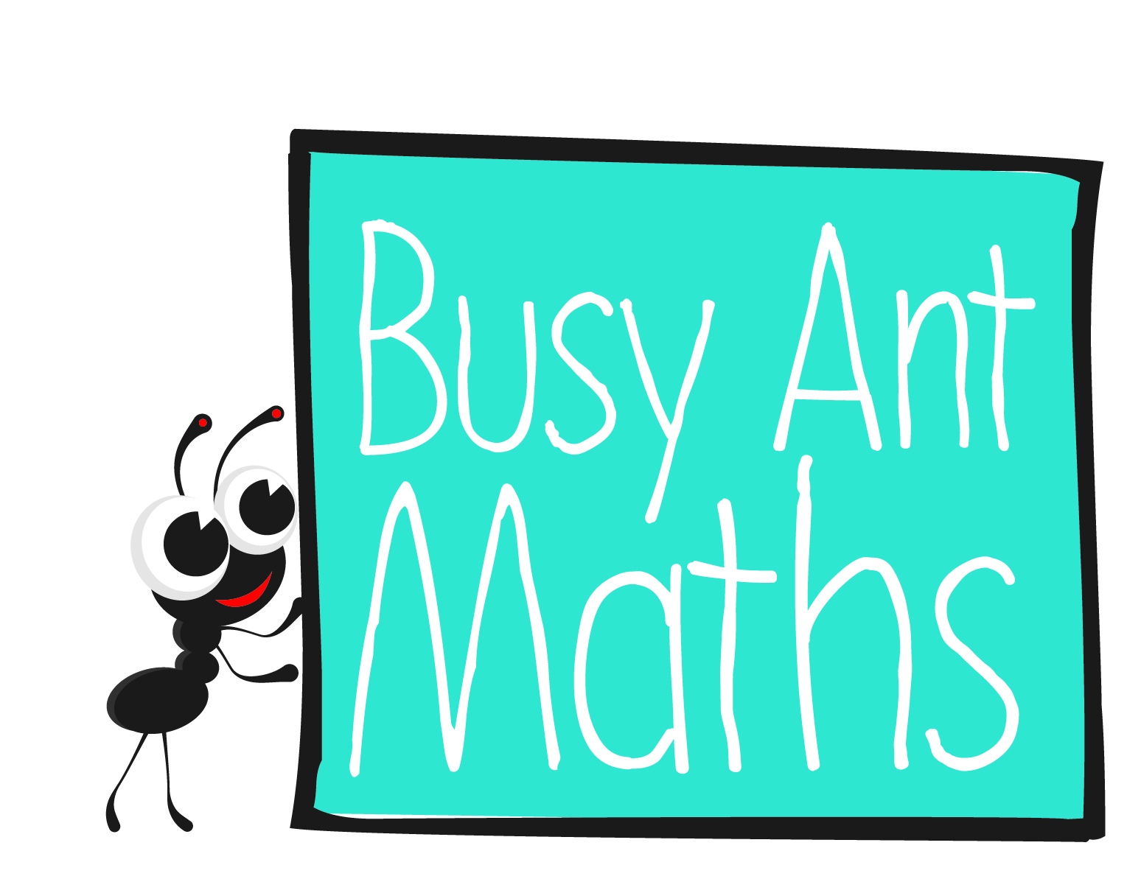
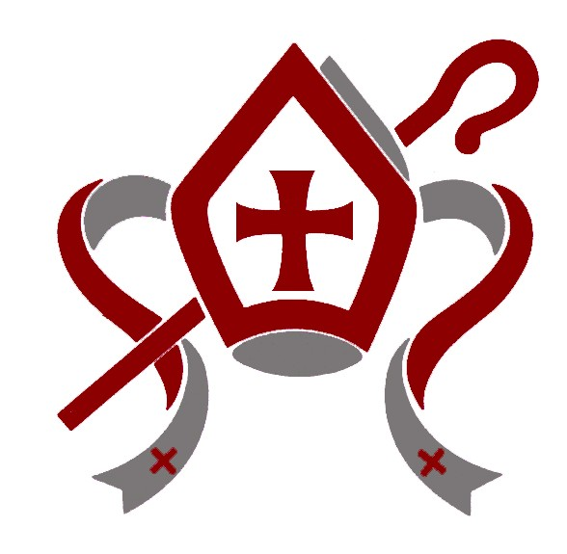
3
2
Measurement (mass)
HERE’S THE MATHS
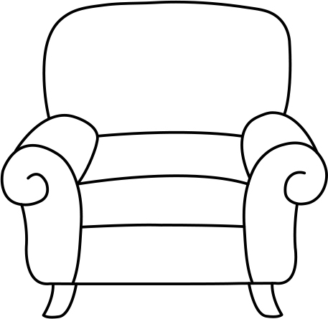
Your child has been ordering objects from lightest to heaviest and weighing objects to find out their mass in kilograms and/or grams.
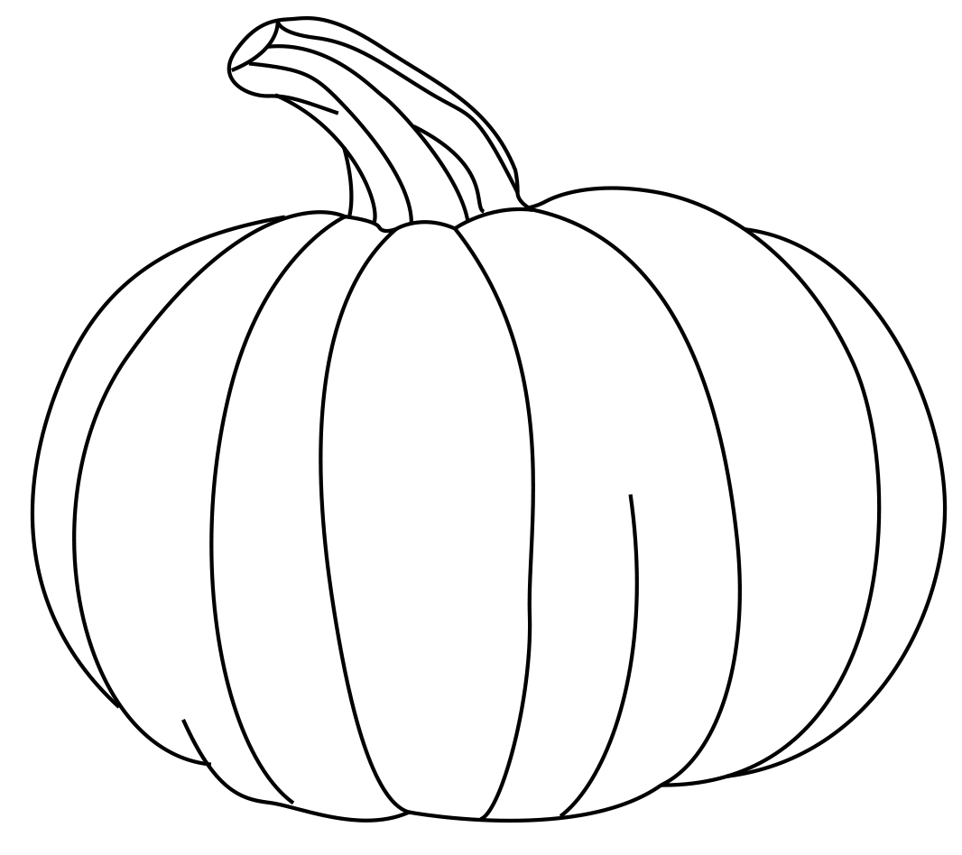
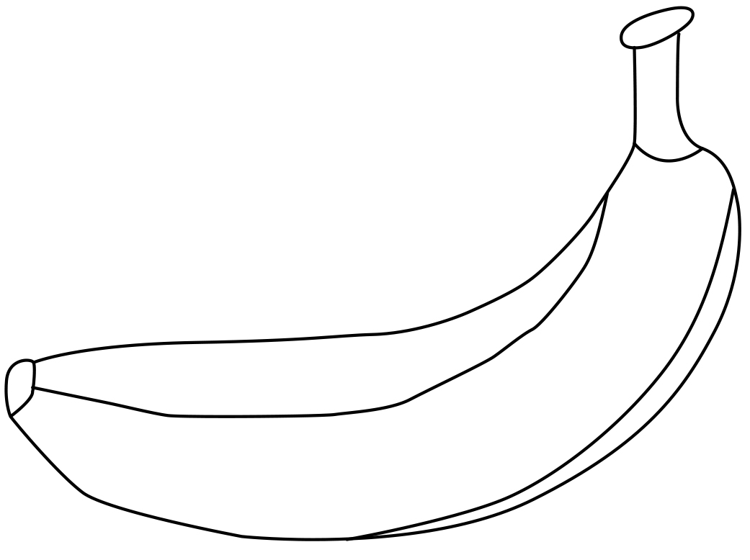
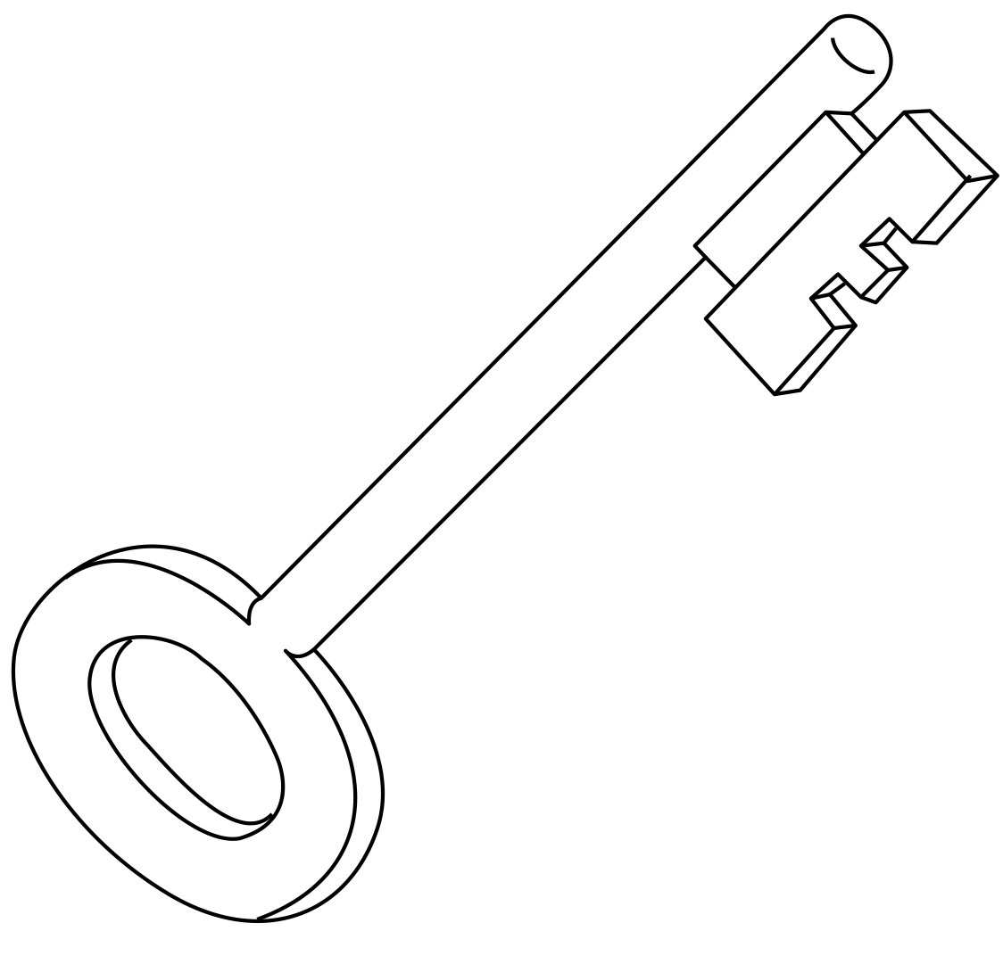
Lightest Heaviest

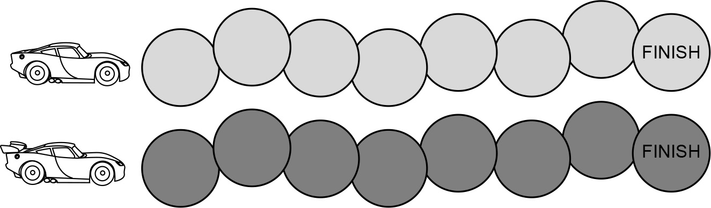
ACTIVITY

What to do
You will need:
- 2 small counters
- 20 everyday objects of different weights (up to approximately 1·5 kg)
- kitchen scales
- Put a counter on each racing car.
- Player 1 takes two objects and decides whether
the second object is lighter or heavier than the first. They check their answer using scales and move their counter one space if correct.
- Player 2 takes the second object from Player 1 and picks a new object. Player 2 decides whether the new object is lighter or heavier than the other object, checks their answer and moves their counter one space if correct.
- Continue playing until someone wins by reaching the finish line.
Variation
- Change the task to working out whether the object is lighter or heavier than 1 kg.
QUESTIONS TO ASK
Which object is lighter/heavier?
Which 2 objects do you think might weigh the same as this object?
Order these 5 objects from lightest to heaviest.
Which objects
do you think will be lighter/heavier than X?

