
Year 5: Summer term 2 Measurement
(volume and capacity)
Topics studied this half term:
- Measurement: converting units
- Volume

Within measurement: converting units, your children will be learning about:
- Kilograms and kilometres
- Milligrams and millilitres
- Metric units
- Imperial units
- Converting units of time
- Timetables

Within volume, your children will be learning:
- What is volume?
- Compare volume
- Estimate volume
- Estimate capacity

Tips for good homework habits:
If your child is struggling, don’t give them the answer in order to finish the homework quickly. Instead, talk through the task together and help them to arrive at the solution themselves.

HERE’S THE MATHS
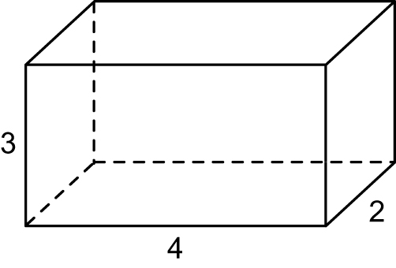
This week your child will be introduced to calculating the volume of cuboids using
1 cm³ cubes. They use cubes (and diagrams of cubes) to count number of cubes
in each layer. They are beginning to establish an understanding that volume equals length × width × height.

1 layer of 3 × 4 cubes = 12 cm³
2 layers of cubes = 24 cm³
ACTIVITY
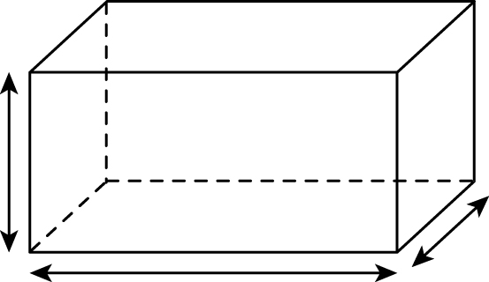
You will need:
- pencil and paper
- two 1–6 dice

What to do
- Each person rolls their dice three times to give dimensions of a cuboid.
- Each person sketches the cuboid and calculates the volume.
- The person with the cuboid that has the greater volume scores a point.
- The winner is the first person to reach 5 points.
Variation
- Use 1–9 cards to increase the number of possible cuboids.
QUESTIONS TO ASK
Change 4070 ml to litres.
How many glasses
of lemonade (250 ml) can be poured from 10 litres?
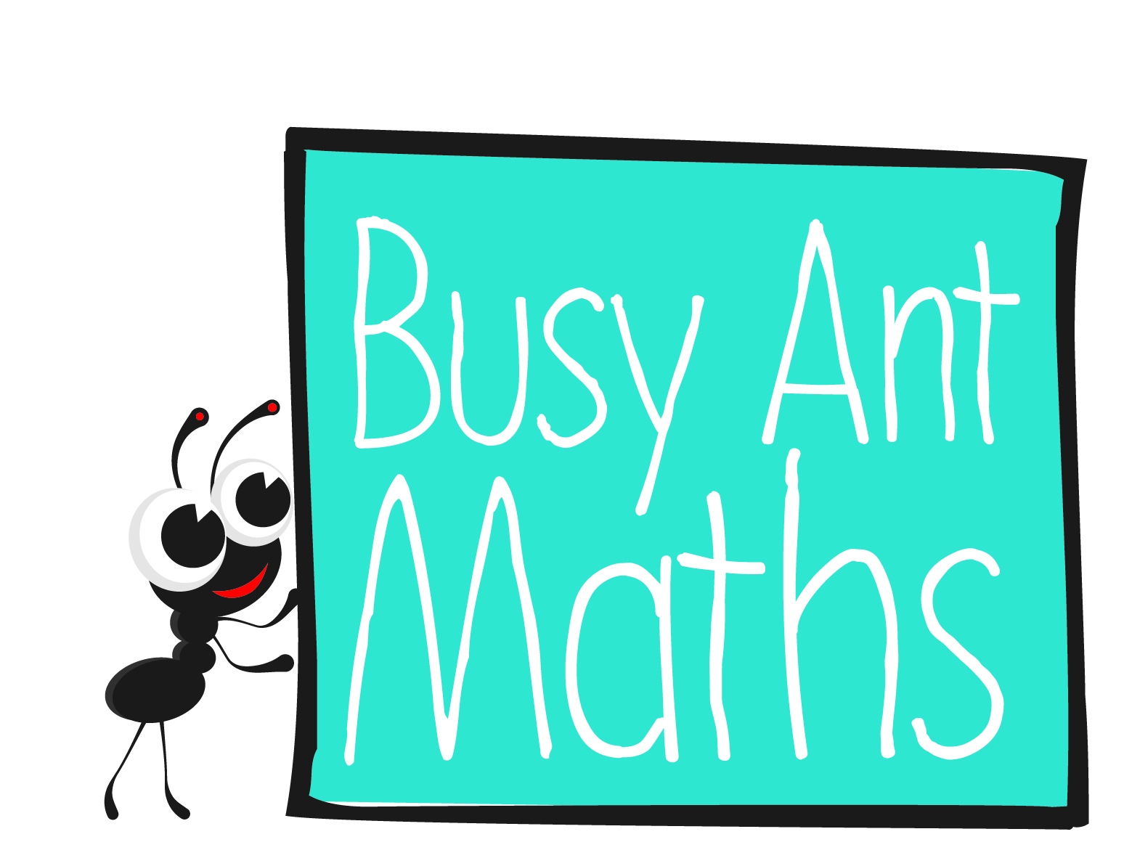
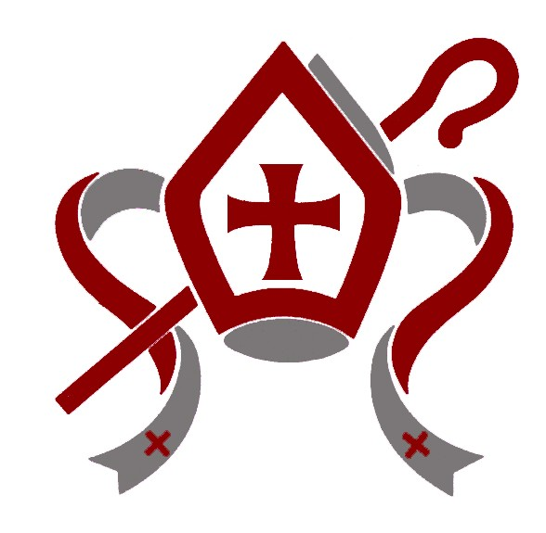
1 litre = 1 $\frac{3}{4}$ pints. Approximately how many pints are there in 5 litres?
How many 1 cm³ cubes are required to make a cuboid 5 cm × 3 cm × 4 cm?
Change 5·25l
to millilitres.

