
Year 5: Summer term 1
Topics studied this half term:
- Properties of shape
- Position and direction

Within properties of shape, your children will be learning about:
- Measuring angles in degrees
- Measuring with a protractor
- Drawing lines and angles accurately
- Calculating angles on a straight line
- Calculating angles around a point
- Calculating length and angles in shapes
- Regular and irregular polygons
- Reasoning about 3D shapes
Within position and direction, your children will be learning about:
- Position in the first quadrant
- Reflection
- Reflection with co-ordinates
- Translation
- Translation with co-ordinates
Tips for good homework habits:
Talk to your child about maths and use a wide range of vocabulary.

Properties of shapes
HERE’S THE MATHS
This week the focus is on the properties of 2-D shapes. Your child is studying rectangles and finding missing lengths and angles. They learn about regular and irregular polygons (2-D shapes with 3 or more sides).
ACTIVITY
1  48 cm | 2  72 cm | 3  100 cm
4  120 cm | 5  96 cm | 6  144 cm

What to do
- The grid shows different perimeters of regular polygons.
- Roll the dice to decide which perimeter to investigate.
- Both sketch and name as many different regular polygons for that perimeter as possible.
- Compare sketches.
- Roll the dice to try another perimeter.
- Play for 10 minutes.
Variation
- Use these perimeters to deduce possible side lengths for rectangles.
QUESTIONS TO ASK
What is the definition
of a regular polygon?
(2-D shape with all the sides equal and all the angles equal.)
What is a diagonal?
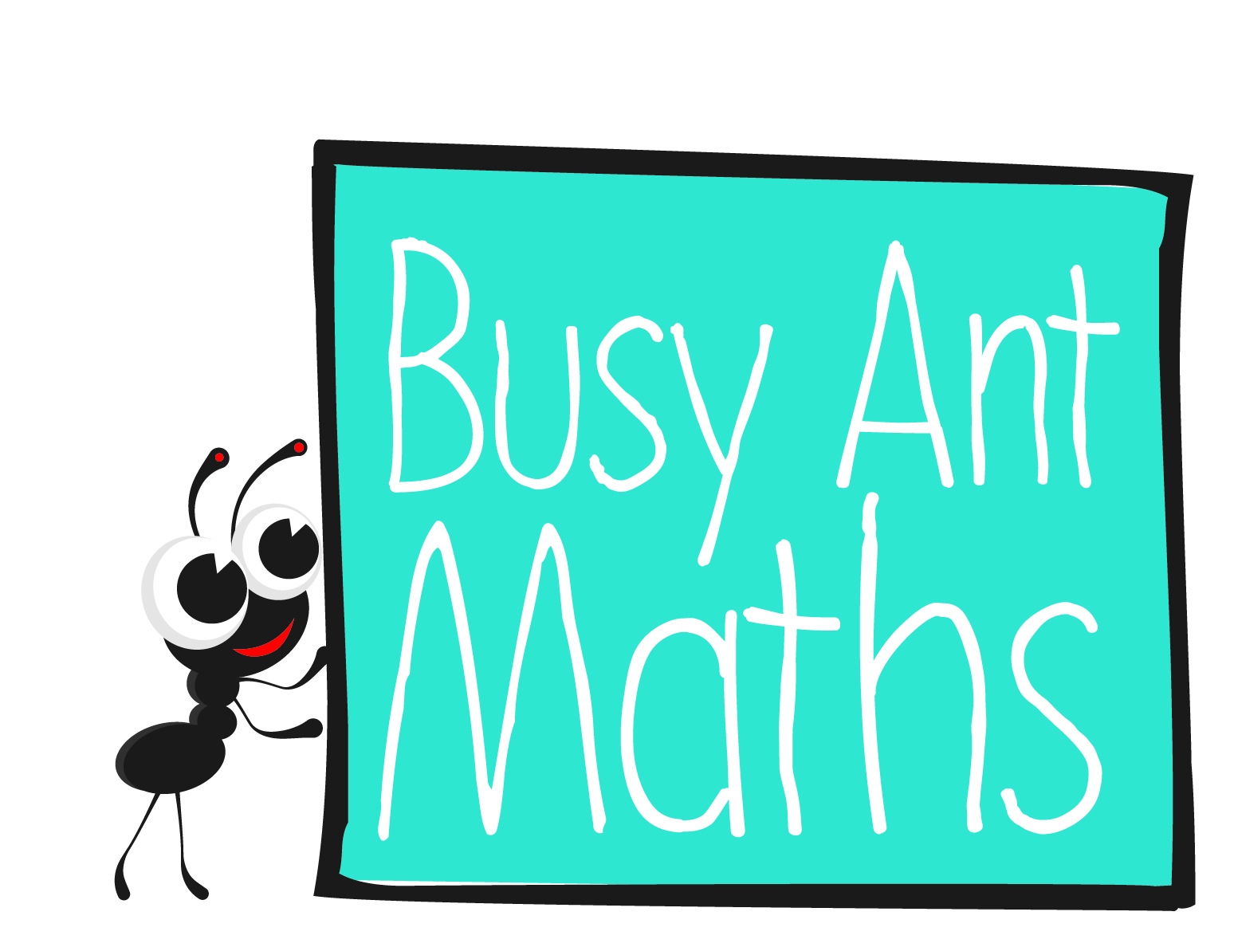
Geometry – position
and direction

What are the conventional signs for a right angle and lines of the same length? (Γ and small lines)
Which quadrilateral can never have a pair of parallel sides? (kite)
Describe the properties of different quadrilaterals.
HERE’S THE MATHS
Your child is learning to reflect a shape using coordinates in the first quadrant. They reflect shapes in different orientations and understand that the shape has not changed but appears as it would in a mirror.
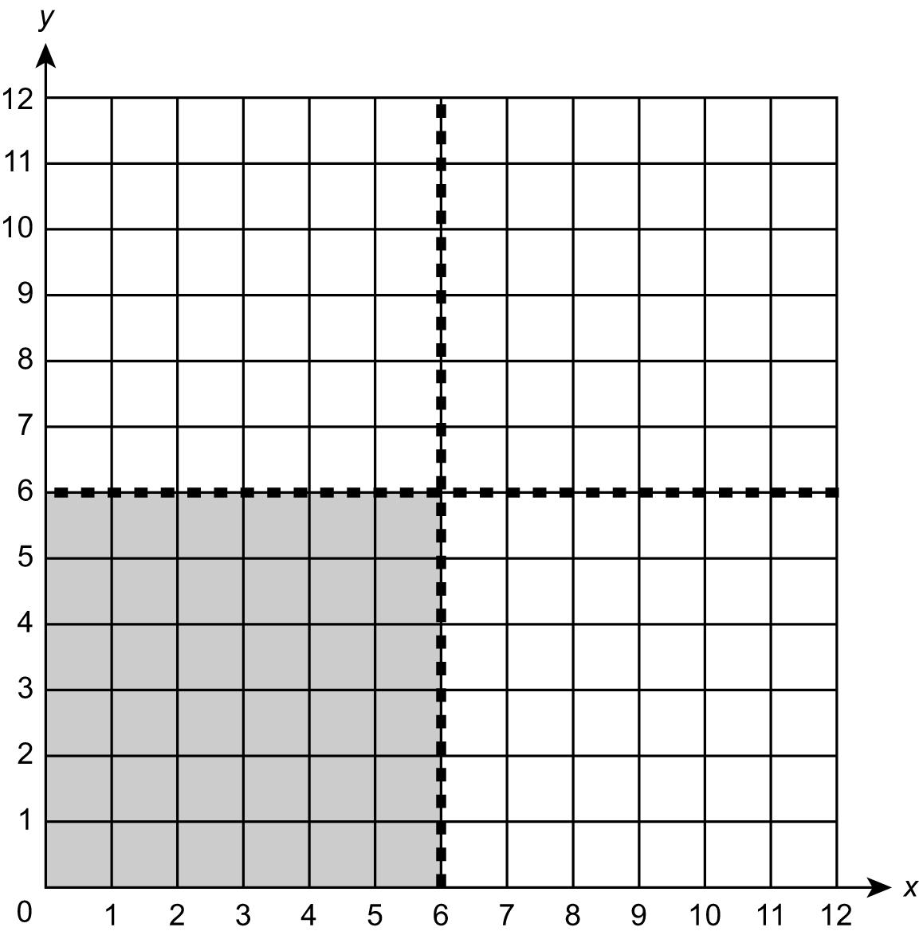
ACTIVITY
You will need:
- pencil, ruler and rubber

Note
The grid is divided into 4 quadrants by two lines of symmetry.
What to do
- One person draws a simple shape within the shaded grey square.
- The second person reflects the shape in the x = 6 mirror line and writes down the coordinates of the new image.
- The first person reflects the shape in the y = 6 mirror line.
- Rub out the shape and images so that the other person can draw a new shape.
QUESTIONS TO ASK
What word do we use to describe the four sections of the coordinate grid? (quadrants)
Which coordinate is plotted first?
(x-coordinate)
What is the reflected shape/image called?

