REASONING 6a - ANSWERS
Which ones have the same answer?
27-7 19+4 7+16 2x10 9+9 9X2
…………………………………………………………………………………………………
Write tallies for these numbers
4 = llll 8 = 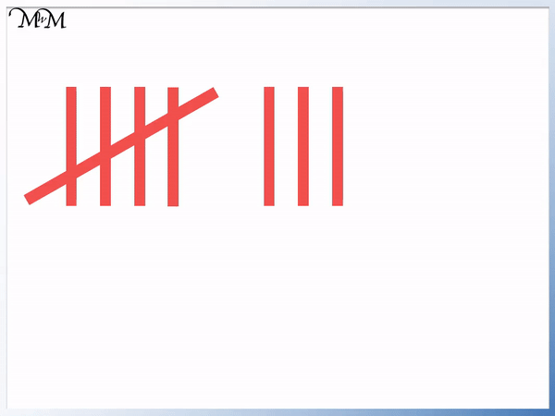 5 =  12 =  16 =l 18 =
……………………………………………………………………………………………...
Look at this sum
63 + 37 = 100
Use this sum to help you fill in the missing numbers
100 - 37 = 63 100 - 63 = 37
………………………………………………………………………………….
Jim’s birthday is in May. Harry’s birthday is the month before Jim’s. What month is Harry’s birthday? April
…………………………………………………………………………………………………………….
Fill in the missing numbers
4 …14…… 24 34 44 ……54…… ……64……. 74 84
……………………………………………………………………………………………………….
There are 56 flowers in Jenny’s garden. 30 of them are red and the rest are yellow. How many are yellow? 26
……………………………………………………………………………………………………….
55 – 30 =
Which of these sums has the same answer as the sum above?
30 – 55= 35 – 10= 35 – 20= 43 – 20= 65 – 40=
…………………………………………………………………………………………………………………
Adam has 22 books on one shelf. He has 16 on another shelf. How many book does he have altogether? 38

