Grammar 21 – Expanded Noun Phrases
An ‘expanded noun phrase’ is a group of words that contain a noun plus other words to tell us about the noun.
the blue butterfly the tall, thin man
the brightly coloured flower
………………………………………………………………………………………………………………………….
Create some ‘expanded noun phrases’ by adding adjectives to describe the noun.
the ………, ………tree the ……………, ………….. dog
the ……….., ………..lady the …………, ………… house
the………., …………… butterfly the ………….., ……..ice-cream
the ………….., ………….pencil the …………, ………… forest
……………………………………………………………………………………………………………………………
Write sentences to go with the pictures.
Use ‘expanded noun phrases’ to make your sentences interesting.
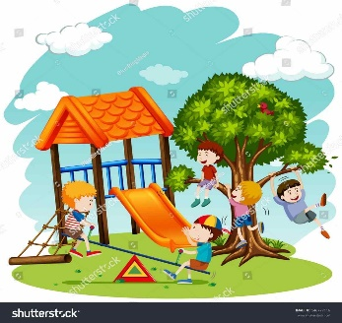 |  | 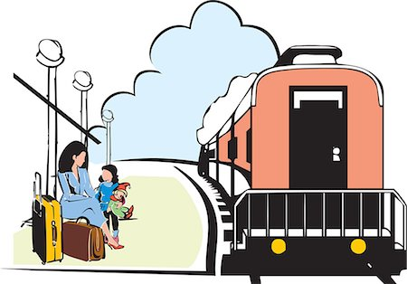
 |  | 
Ask somebody to check your work.

