
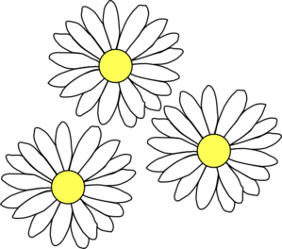
…Year 2
Next stop…

Passport to my New Class
Dear Parent,
Thank you for taking the time to work through this booklet with your child in preparation for September. To help us support your child further, I would be grateful if you would let us know of anything you feel your child may need support with when they return to school. In addition to this, you may wish to let us know of any difficulties that the family have encountered throughout the pandemic. Sometimes, even the smallest things can unsettle a child and so anything you feel comfortable to share will help us to help your child.
If you would like to add your comments here, please do so. Alternatively, please contact Miss Marshall, our Parent Support Advisor via email missmarshall@st-anselms.kent.sch.uk
Thank you for your support and cooperation.

This is me!

Draw a picture of yourself here
My name is
What do you like to do in your spare time?
Ask someone at home to write what they like about you
Draw and label a picture of people in your family
What I like about myself

What do I think will be the same
when I go back?
What do I think will be different when I go back?

What are you looking forward to at school?
- Seeing my friends
- Meeting my new teacher
- School dinners
- Playing
- Learning

Things I need help with
Things I am good at
At school

What made me sad during lockdown
What made me happy during lockdown

Who have you been at home with during lockdown?
Draw a picture of your favourite thing to do at home
At home

Thank you so much for telling me all about you.
I can’t wait to welcome you back to school in September!
Have a lovely summer! Take care and stay safe.
Others will know when I feel sad or worried because…
Things that make me sad or worried are…
Others will know when I feel happy or excited because…
Things that make me feel happy or excited are…
My feelings

